COME JOIN US IN THE 4TH ANNUAL OES MOTORCYCLE RIDE
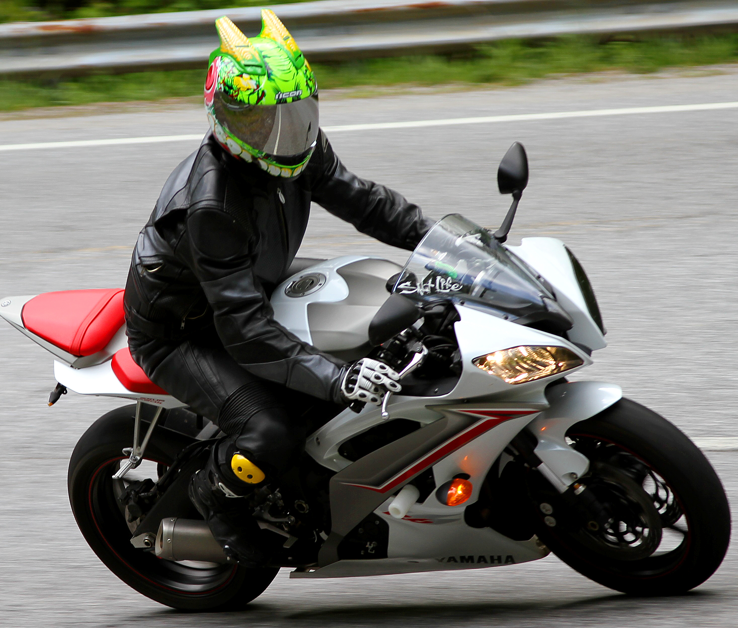  Come and Enjoy the Ride!!!! |  | Saturday, May 31st 2014  REGISTRATION: 9:00AM  KICKSTANDS UP AT 10:00AM  PLACE: MT.YONAH LODGE  59 WHITE STREET CLEVELAND GA.30528  CONTACTS: DEBI PETERS 706-892-4651  TIA PETERS 706-892-4652
REGISTRATION FORM
Registration fee is $20 per bike. On site registration is available. Please allow enough time for registration. Fees will go towards Childrens Christmas Fund, Helping the White County Community and as always Thank You for your Support.
Motorcyclist Name:__________________________________________________________________________________Name of Passenger:_______________________________________________________________________ Address:________________________________________________________________________________City:____________________________________________State:____________________Zip:____________Email:__________________________________________Phone:___________________________________
I accept full responsibility for the motorcycle I have entered. (Motorcyclist/Owner) ___________________________________________________________________ Bike Registration Fee: $20_____________________Total Amount Paid: $___________________________
LIABILITY WAIVER: I hereby release and agree to hold harmless, Mt. Yonah Chapter 405 OES, the directors, sponsors, representatives, volunteers, and employees of them all, of liability, loss, claims, and demands, that may occur from any loss, damage, or injury(including death to my person or property) in any way resulting from, or arising in connection with this event, and whether arising while engaged in competition or practice or preparation therefore, or while upon entering or departing from said premises, from any cause whatsoever. All riders are expected to obey all traffic laws, to include, but not limited to posted speed limits. I know and accept the risk and danger to myself and my property while upon said premises or while participating or assisting in this event, so voluntarily and in reliance, upon my own judgment and ability, and I hereby assume all risk for loss, damage, injury, (including death to myself or my property) from any cause whatsoever. I also release the rights to have my picture or pictures to be used in any OES publications.
Signature_______________________________________________________________________________
Passenger Signature:_______________________________________________________________________________

